Dear @Khaled Khalil,

Kindly align the resource for below mentioned issue observed in Zain KW ;

Please check below issue reported by the customer now

Below items are available in Unmapped Passive - despite of being capitalized.

Element ID | Element Type | Parent NE Type | Site ID | Category
2102311VBKN0L9008722 | Passive | Passive-Data | 7 | Not Classified_Not Classified
PO#84577_DIGITAL-SW-LINE#01 | Passive | Passive-Data | HQ1 | Passive Hardware
tower0850 | Passive | Passive-Data | 58 | Civil Elements_Tower

Below samples, please check if only clean up needed or there is an issue.

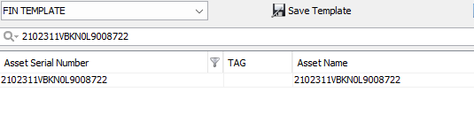

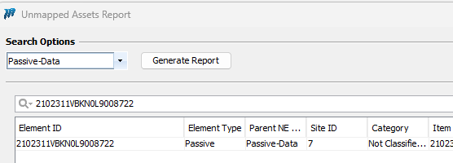

Will raise JIRA once it will work.

